**Project Design Phase-II**

**Data Flow Diagram & User Stories**

|  |  |
| --- | --- |
| Date | 23 October 2023 |
| Team ID | 592350 |
| Project Name | Deep Learning Model for Eye Disease Prediction |

**Data Flow Diagrams:**

A Data Flow Diagram (DFD) is a traditional visual representation of the information flows within a system. A neat and clear DFD can depict the right amount of the system requirement graphically. It shows how data enters and leaves the system, what changes the information, and where data is stored.

DFD Level 0 –

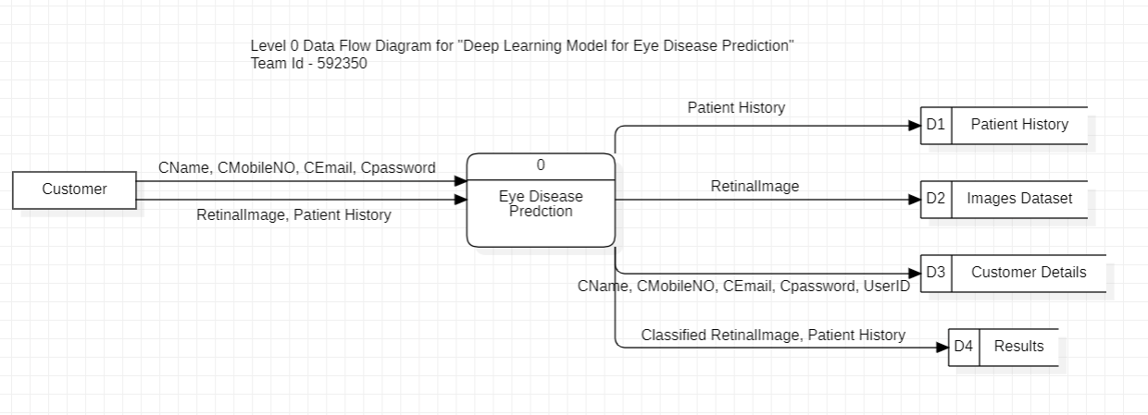

DFD Level 1 –

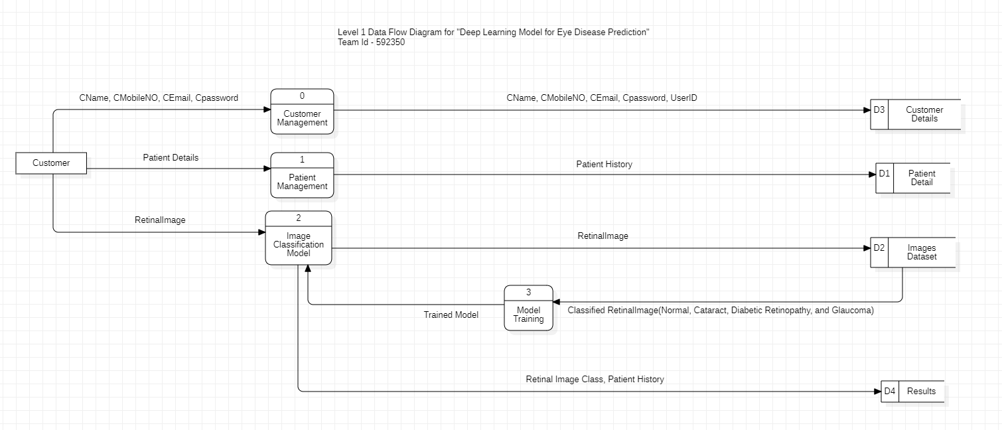

DFD Level 2 –

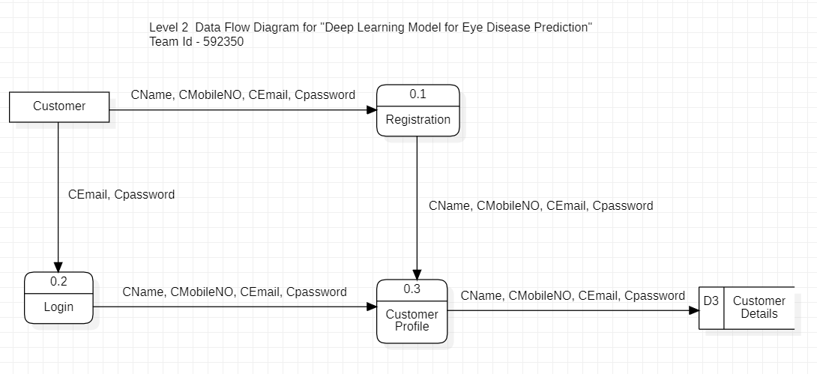

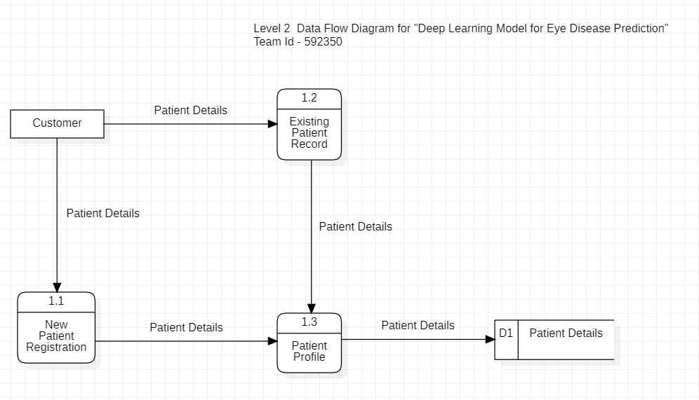

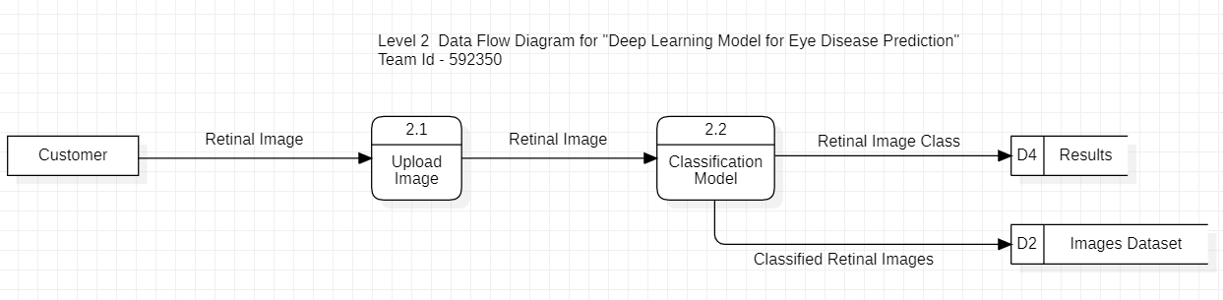

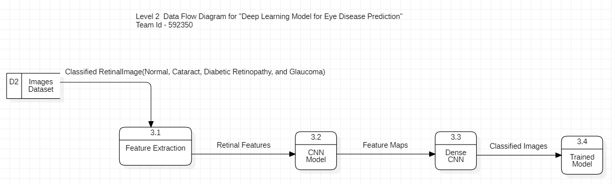

**User Stories:**

|  |  |  |  |  |  |  |
| --- | --- | --- | --- | --- | --- | --- |
| **User Type** | **Functional Requirement (Epic)** | **User Story Number** | **User Story / Task** | **Acceptance criteria** | **Priority** | **Release** |
| Customer / Healthcare Professionals | Registration | USN-1 | As a user, I can register for the application by entering my name, email, Mobile number, password, and confirming my password. | I can access my account / Home page | High | Sprint-1 |
|  |  | USN-2 | As a user, I will receive confirmation email once I have registered for the application | I can receive confirmation email & click confirm | Low | Sprint-3 |
|  | Login | USN-3 | I want a secure login process to the dashboard using my credentials, enabling me to access classification results and patient data. | I can access my account / Home page | High | Sprint-1 |
|  | Home Page | USN-4 | I prefer a user-friendly dashboard interface with clear instructions and tooltips, facilitating easy navigation and utilization of features without any confusion. | I can access my home page | Medium | Sprint-3 |
|  |  | USN-5 | As a user, I want to be able to add new patient records to the system so that I can keep track of their medical history and provide them with better care. | I can add new patients | High | Sprint-1 |
|  |  | USN-6 | I need the ability to search for specific patients using unique identifiers like patient ID or name, allowing for swift retrieval of their classification history. | I can view patient’s records | High | Sprint-2 |
|  | Classification | USN-7 | As a user, I want to be able to upload fundus images of my patients to the system so that I can get a better understanding of their eye health and diagnose eye diseases more accurately. | I can upload Fundus images of my Patients | High | Sprint-2 |
|  |  | USN-8 | I require access to detailed classification reports for each patient, containing images, date of classification, and identified eye condition, aiding in my diagnosis process. | I can view the details of classification | High | Sprint-2 |
| Administrator | Administration | USN-9 | As an administrator, I require the capability to reset user passwords and provide support for users who may have forgotten their login credentials. | I can reset user passwords | Low | Sprint-4 |
|  |  | USN-10 | I need the dashboard to feature an intuitive user interface for managing user accounts, simplifying tasks like account creation, modification, and deletion. | I can Create/Modify/Delete accounts | Low | Sprint-4 |